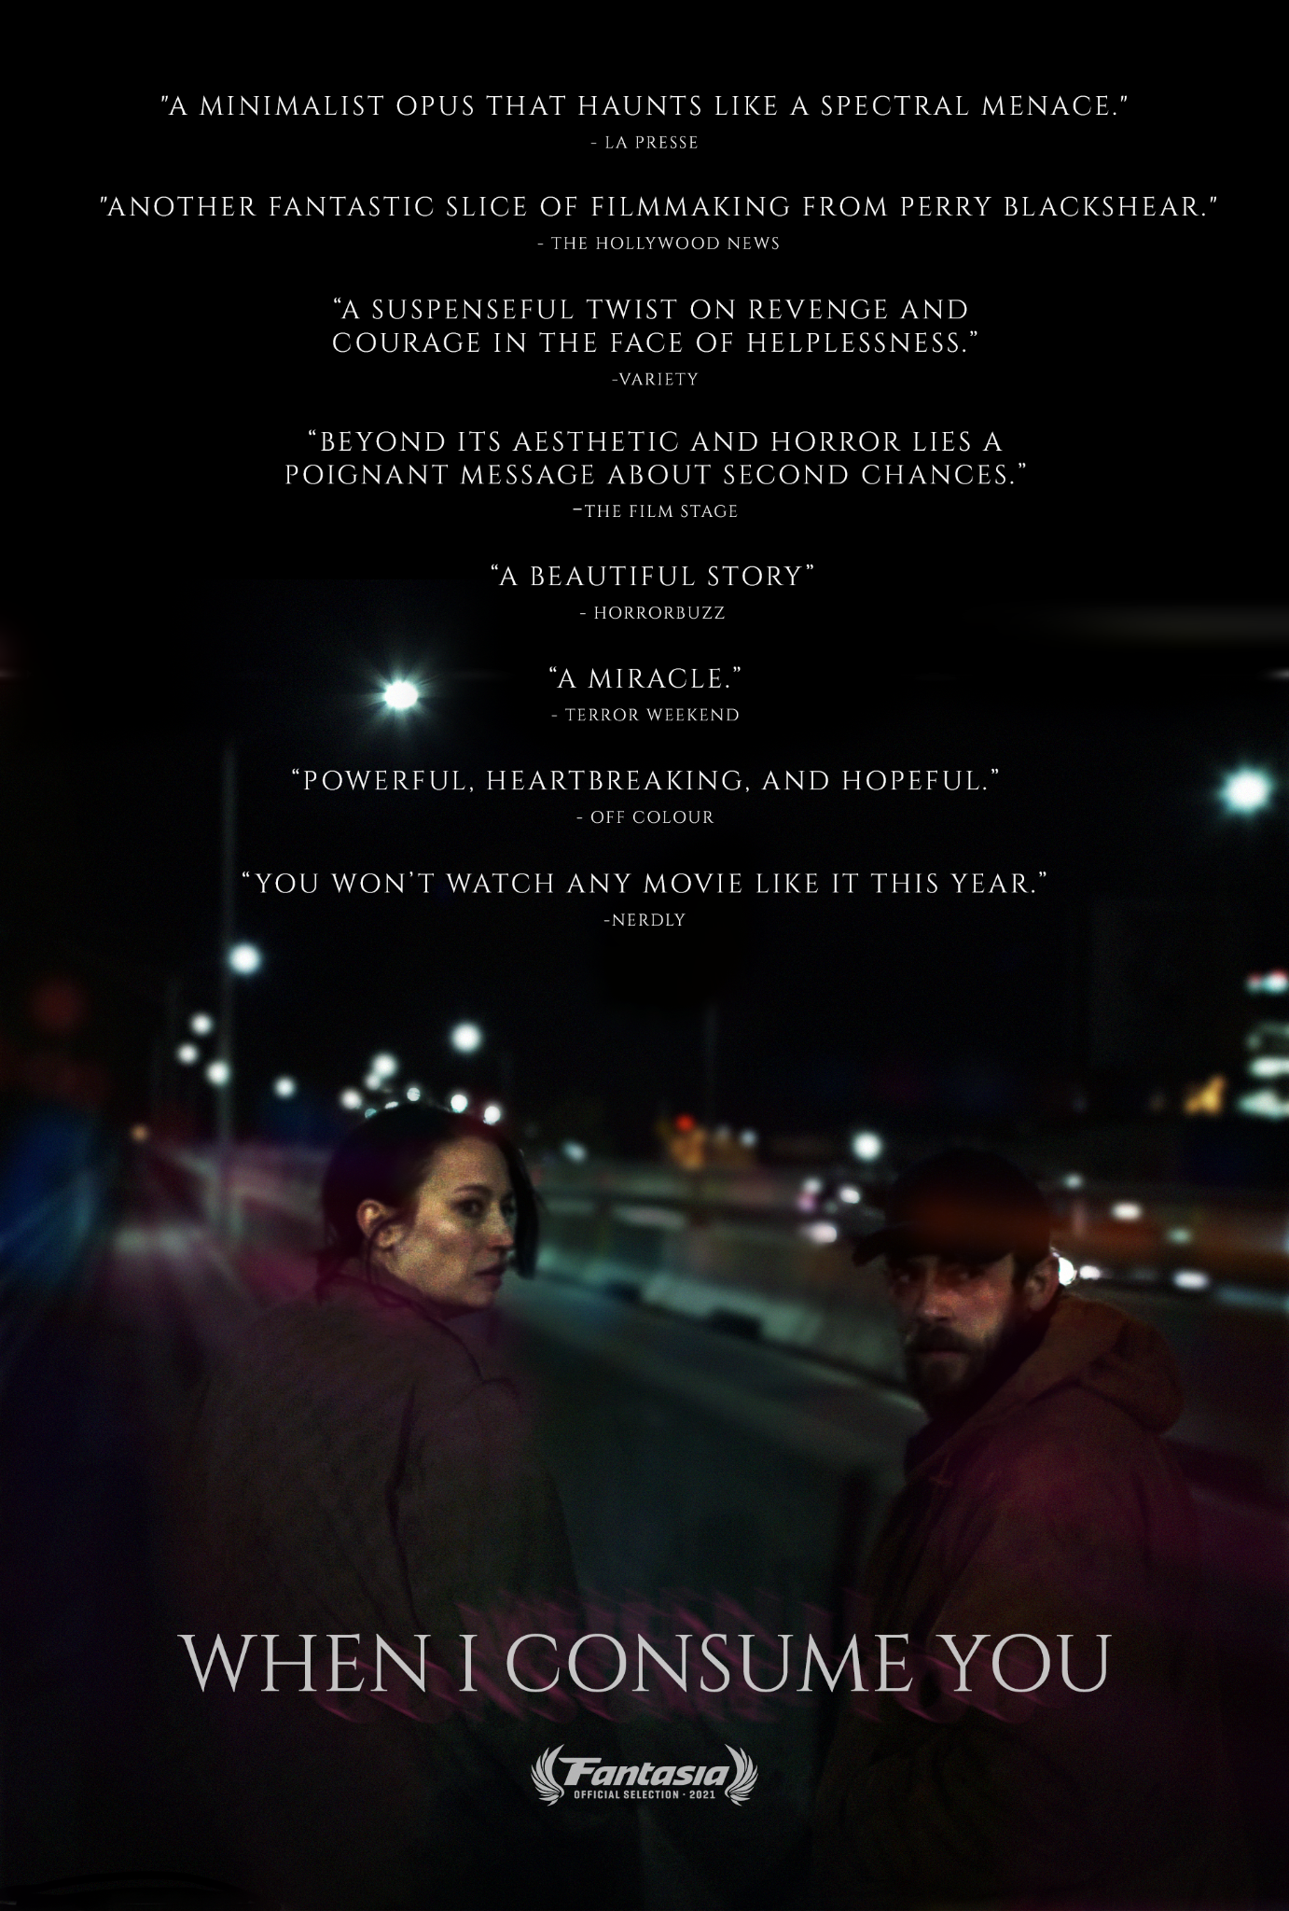
A film by Perry Blackshear
2021 / USA / English / Supernatural-Mystery
90 min / 4K / 16:9
www.wheniconsumeyou.com
hello@ahabandthedark.com
PRESS

“Of all the films shown at Fantasia this year, When I Consume You by Perry Blackshear is one of the most successful. Haunting, distressing, destabilizing, this quest for a brother to rescue his sister is blood-curdling, recalling how independent American cinema is still capable of great things.” - Martin Gignac, LA PRESSE

“A captivating revenge tale …provides realism and a grounded narrative that should appeal to horror and non-horror fans alike. “ - Brian Fanelli, Horror Buzz

“When I Consume You is also very tangible in its tenderness, in this humanity, in this empathetic gaze that it offers to its imperfect characters, but also in this touching candor that it grants them. Above all, it is a perfectly lucid film which anchors fear at the level where it is really situated in life: at street level.” -Olivier Thibodeau, PANORAMA CINEMA

“The cast is phenomenal, Libby Ewing and Evan Dumouchel have incredible chemistry here portraying brother and sister. …The rawness and subtlety of their performances anchor the more fantastical elements of the narrative and earn every laugh, tear, or blood spill. The two actors went for broke, and their efforts come across with every frame.” - K.B. O'Neil, SCARYNERD

“…poetic horror movie that has just as much strength in the supernatural side as it does in its heady drama.” - Vanessa S., MOTHER OF MOVIES

“When I Consume You is complex and compelling, blending elements of horror, fantasy, drama, and thriller to produce an atmospheric and haunting story that really stays with the viewer after watching.” - Kat Hughes, HOLLYWOOD NEWS

“The more I attempt to describe it, the more insane it sounds, but trust me, Perry Blackshear makes it work in spades.” - Carlos Ovalle, BUT WHY THO

“The film is disquieting, throwing you off-kilter even once you believe you’ve got the hang of things. Unexpected in intriguing ways...I’ll definitely be thinking of it for a long while after.” - Jay, ASSHOLES WATCHING MOVIES

“The siblings are played by Libby Ewing and Evan Dumouchel. Not only are their individual performances superb, but their chemistry together is magical. It truly feels like you’re watching siblings desperate to save each other. Another memorable performance comes from MacLeod Andrews, who is able to change his on-screen persona at the drop of a hat.” - Molly Henery, THE BLOGGING BANSHEE

“Writer/Director Perry Blackshear has quickly become an articulate and powerful filmmaker within the horror genre.” - A. W. Kautzer, THE MOVIE ISLE

“The final third is when things really ramp up. Everything comes together, there’s surprises, there’s more action and everything you hoped to happen, happens. Blackshear clearly knows how to end a movie.” - Alain Elliott, NERDLY

“Beautiful, affecting but with plenty of scares and horror trappings, When I Consume You is a wonderful example of how powerful horror can be, especially when it is ultimately a story of hope.” - SCARED SHEEPLESS

“Perry Blackshear's excellent When I Consume You more than lives up to his debut (They Look Like People), and delivers deep melancholy, grief and hard-won love within its supernatural tale. Superbly acted, too. Hugely recommended!” - Pope, WHITLOCK & POPE

“…surprisingly engaging middle ground between a bleak family focused neo noir and updated folklore…” - G.G. Graham, WICKED HORROR

“When I Consume You is the sort of horror film that will stick with you. Not for the moments of gore and violence (although they are memorable), but for the tender story told here underneath the nightmare Wilson is trying to get away from. There is a balance between realism and fantasy that writer/director Perry Blackshear excels in; working with a barebones cast and crew in Brooklyn, there’s an intimacy and emotionality that is often missing from large productions. When I Consume You feels special; like the kind of film that doesn’t come around often.” - Juli Cabot, AIPT COMICS

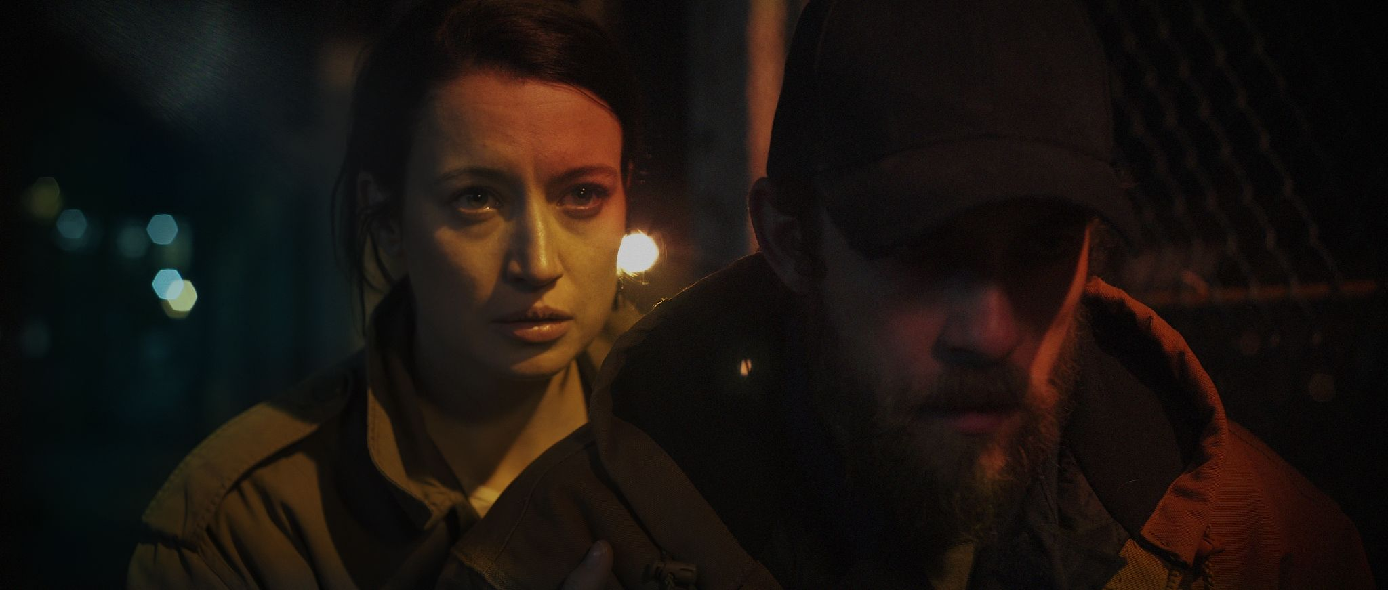

Logline

A woman and her brother seek revenge against a mysterious stalker. A gritty, slow-burn urban folktale about family, damnation, and redemption.

Synopsis

Siblings Daphne and Wilson Shaw practically raised one another. They’ve protected each other from everything life has thrown their way. Daphne’s professional life is soaring and she’s looking to adopt a child. Wilson is interviewing for a position at a local school, hoping to become a teacher. But Daphne has an unsettling, dangerous stalker whom she can’t seem to shake, and now threatens to destroy them both. They hunt for their tormentor through the shadowy streets of Brooklyn, honing their bodies and minds for a showdown. But this foe may prove to be more than they can handle. They will break and rebuild themselves if necessary to save each other, and protect the light they know is in this world for them... if only they can persevere.

Main Cast & Crew

Writer/Director/Cinematographer Perry Blackshear

Producers Perry Blackshear, MacLeod Andrews,
Evan Dumouchel, Libby Ewing

Wilson Shaw Evan Dumouchel

Daphne Shaw Libby Ewing

David Castille MacLeod Andrews

Director’s Statement

The experience of watching frightening movies to me feels like undergoing an ancient ritual: feeling the terror of death, and resurrecting in the theater when the lights come up, OK again and happy to be alive. You touch darkness, but you survive. But what happens when we touch darkness every day? When the world is a nightmare, why make nightmarish films? This is a question I was asking myself as I was editing When I Consume You over the last year and a half.

When I Consume You is the darkest film I’ve made. We reassembled the cast and producing team from my first two films with the addition of the incredible Libby Ewing, and shot on the streets of Brooklyn with our small crew during the winter. With a team this intimate, the film becomes personal whether you want it to or not. The pain of growing up, the struggle of knowing how to be hard enough to fight but soft enough to love, burned through the cast and crew. As I finished the edit, I realized the film isn’t just a slow-burn nightmare. Despite its grit and sadness, the film is fundamentally hopeful. This is why I love it. There is a hard-won steady message within the movie that emerged as we were all making it that continues to give me heart: The world is hard. Evil can never be defeated. Loving can bring pain. Live anyway. Fight anyway. Love anyway. -Perry Blackshear

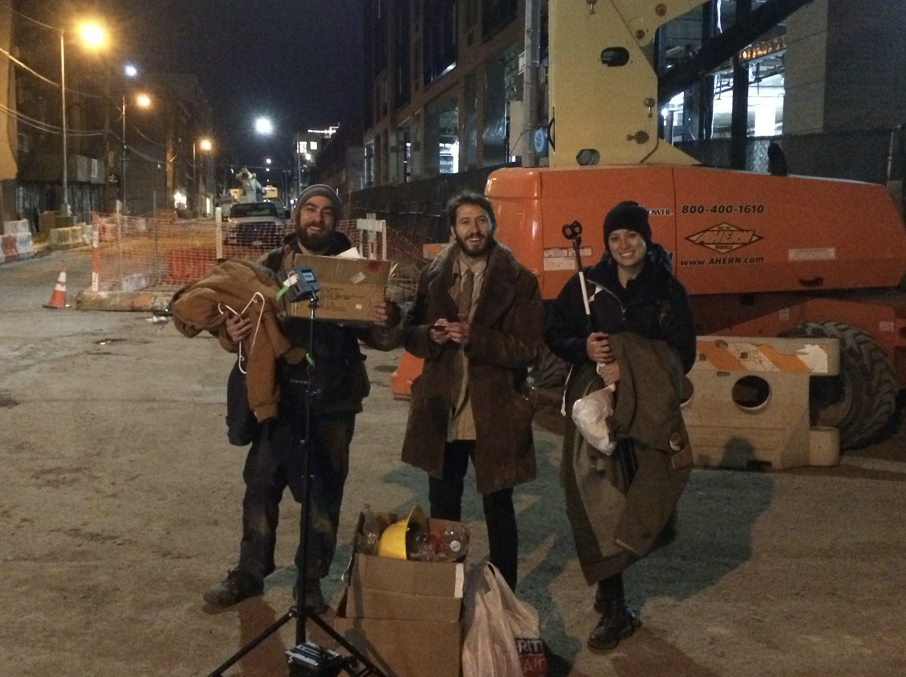
The cast... and also the crew, after the alleyway scene.
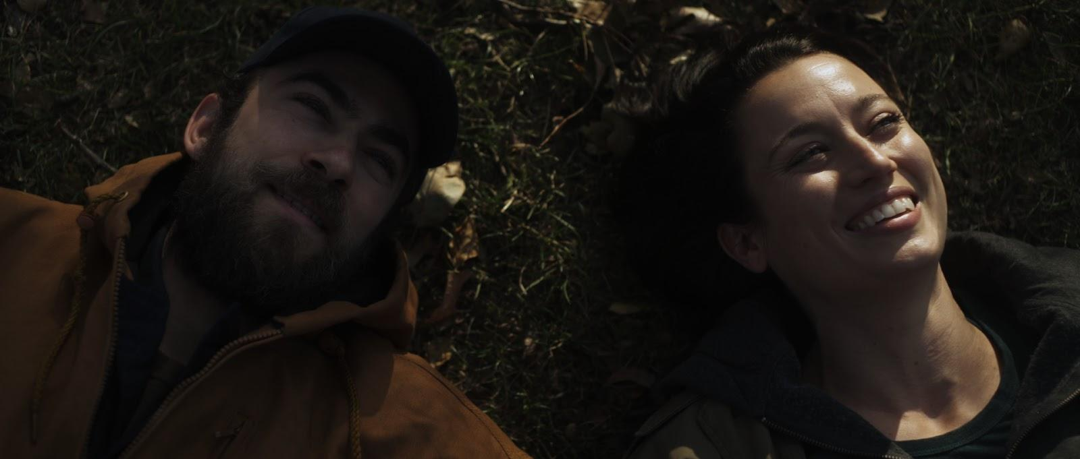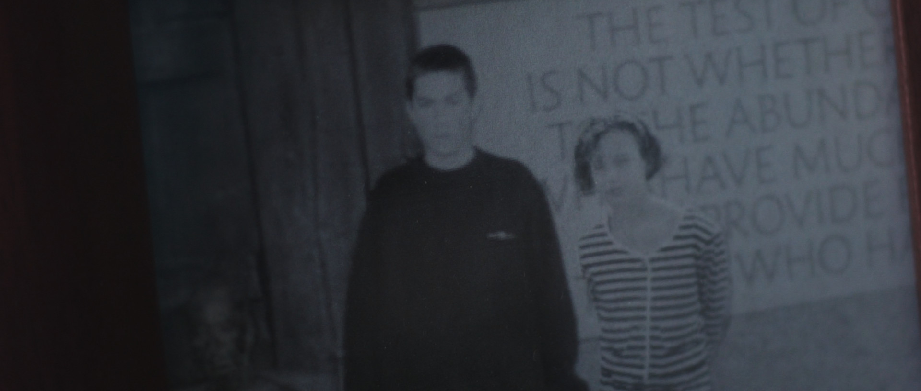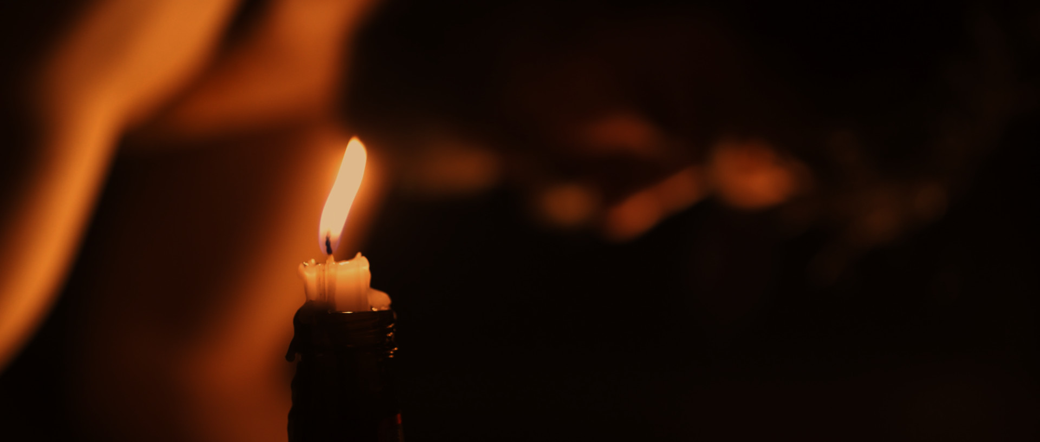

Perry Blackshear
Writer, Director, Cinematographer, Editor

Perry Blackshear is a filmmaker from North Carolina. He earned his MFA in Directing from NYU Graduate Film School. His first feature, They Look Like People, became an international film festival darling and won dozens of awards including the grand jury awards at Slamdance, IFF Boston, and Nashville, and most innovative film at Fantasia. It went on to play theatrically before landing at Netflix. His second feature film The Siren was acquired by Dark Sky. Perry recently sold an original TV show to Netflix and completed a writing project for Amazon. He is repped by CAA. Perry enjoys joy-sobbing to music and friends that are like family.

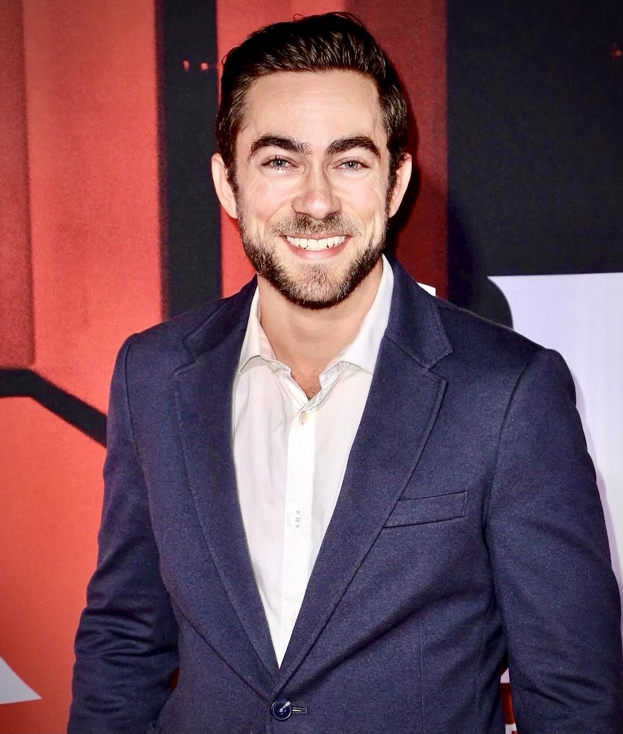
Evan Dumouchel
Wilson Shaw, Producer

Evan Dumouchel is an award-winning actor and producer based in Los Angeles. Some favorite acting credits include They Look Like People, The Siren, Doctor Sleep, and When I Consume You (THIS MOVIE!). He is currently developing several television projects and loves making art with his closest friends.


MacLeod Andrews
David Castille, Producer

MacLeod Andrews is an actor and producer based in Los Angeles. He played Wyatt in and produced 2016 indie suspense hit They Look Like People, followed by The Siren. Recently he co-wrote, produced and starred in cult favorite A Ghost Waits which was picked up by Arrow Films. He has performed on the stage in many Off-Broadway, West Coast, and World premieres, enjoys a thriving voice over career, and is a multiple award-winning audiobook narrator with over 400 titles to his credit (The Sandman Slim series by Richard Kadrey being a favorite), and has a comical affinity for chocolate chip cookies; you can guess which muppet he would be.


Libby Ewing
Daphne Shaw, Producer

Libby Ewing is an actor, writer, and director based in LA. Her TV/Film credits include Murder in the First, House of Lies and Scorpion, among others. Recently, she co-created the digital series, Grow the F*ck Up and made her directorial debut helming two episodes and won “Best Director” at the 2019 Austin Comedy Short Film Festival for the Mack of All Trades Pilot. She loves nothing more than creating with her nearest and dearest.

